Simple Distillation of a Volatile Liquid
Containing Non-volatile Impurities

Assemble the simple distillation apparatus as shown in the pictures below. Use a 100 mL round-bottomed
flask for the still pot.

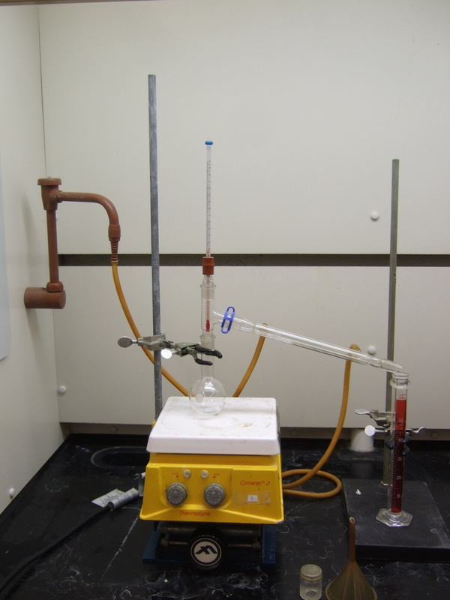

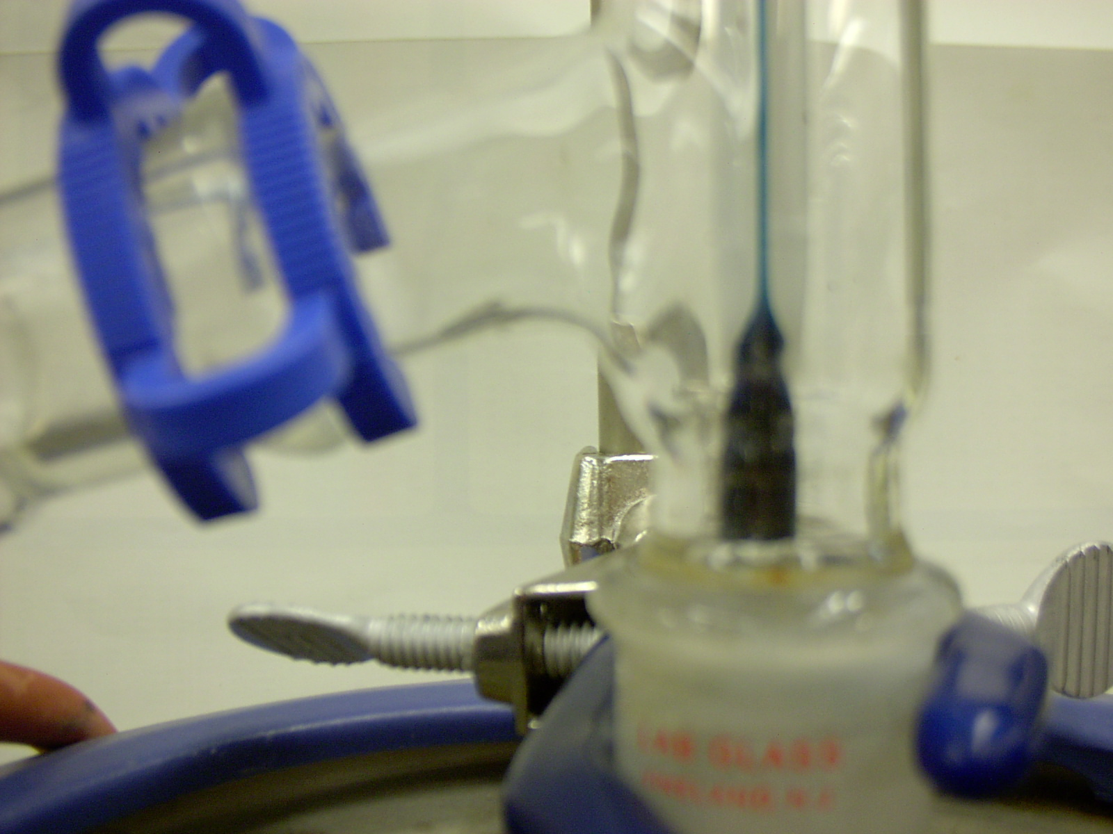

Have your instructor check your apparatus for proper assembly.

Remove the Thermometer/adapter assembly from your apparatus, and insert your long-stem
plastic funnel.

Pour 50 mL of cyclohexane ( B.R. 80 - 82ºC ) through the funnel into your apparatus.

Note the color and clarity of your pure liquid on your laboratory data sheet.

Remove the funnel from your apparatus and add your magnetic stirring bar.
Replace the thermometer/ adapter assembly onto your apparatus.

Have your instructor check your apparatus before you start heating.

Place a 50 mL graduated cylinder so that the tip of the condenser is centered over the neck
of the cylinder, as shown on the demonstration set-up.

Turn the water on so that a gentle flow comes from the discharge end of the apparatus.

Statr stirring and begin heating the distillation flask on a setting of “4”.

As soon as the liquid begins to boil and the condensing vapors have reached the thermometer bulb,
regulate the heat supply so that distillation continues steadily at 1 drop per second.

As soon as drops begin falling into the receiver, record the temperature from the thermometer in the
distillation head. Record the temperature every four mL thereafter.

Discontinue heating when only 2-3 mL of your pure liquid remains in the distillation flask

Pour the contents of your receiver into the recovery bottle.

Draw a Temperature vs. Volume graph of your lab data on your laboratory report form.

Note the boiling range of your pure liquid on your lab report form, and note the color and
clarity of your distillate.

Che 301 Su’2008

Lab Data Sheet

Title: Simple Distillation

Name:___________________________________________ Locker #:___________

Date:______________________________

Lab Data

Liquid Used:_________________________________

Appearance of the liquid
( circle the appropriate description(s) )

Colorless color cloudy clear

other comments______________________________________________________________

Volume of Liquid Used: mL.

Temp. at which first drops enter the receiving vessel: ___ ºC

Volume/Temp Data

Vol (mL) | 4 | 8 | 12 | 16 | 20 | 24 | 28 | 32 | 36 | 40 | 44
Temp
(ºC)

