Steam Distillation

The purpose of this experiment is to demonstrate the ability to distill an organic liquid at a temperature considerably below that of the boiling point of the pure liquid.

Procedure

Construct the steam distillation apparatus as below. Use a wide-stem funnel to add your pulp/water

mixture the 250 mL RBF ( UNTIL a bit OVER HALF FULL ) – then assemble the remainder of the

apparatus.

.

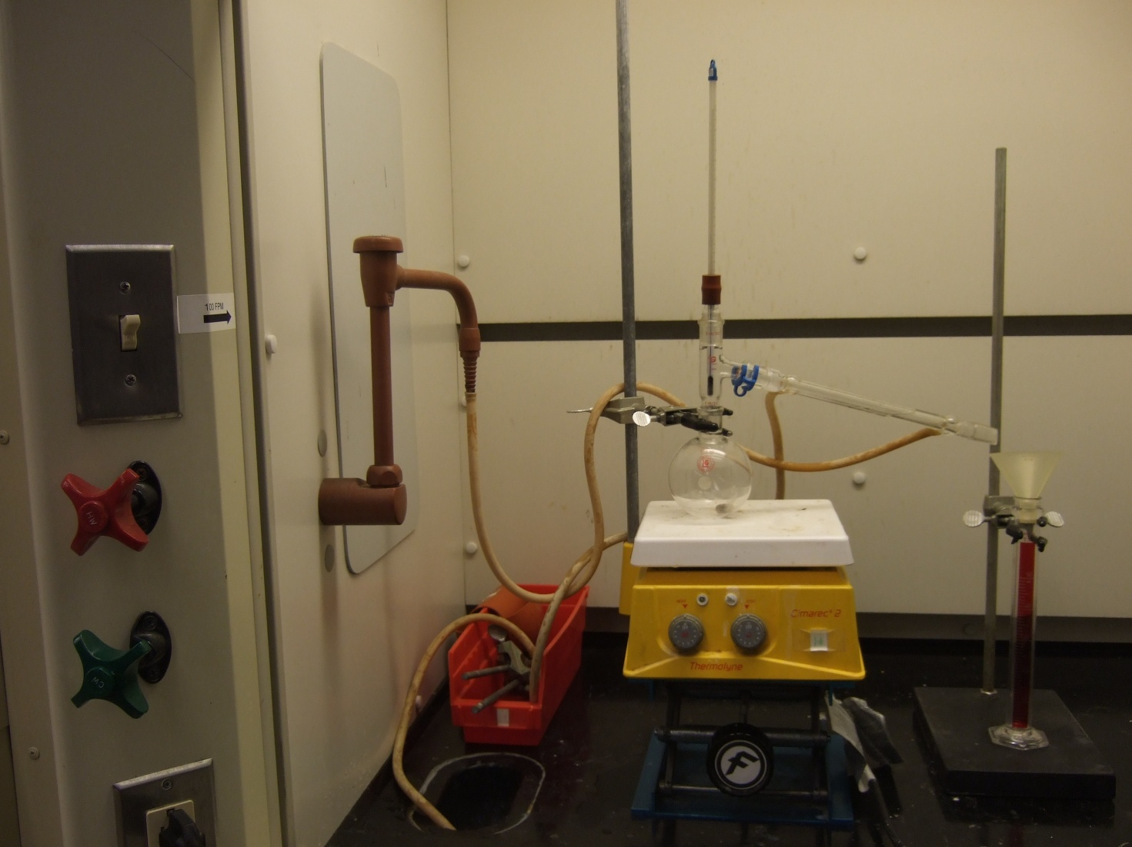

Heat the mixture to a boil, initially heating at “10”.

Note: Attempt to control the rate of heating so that excessive foaming does not occur.

At the first drop of distillate, record temperature and volume of distillate collected ( 0, for this reading ). Once 40 mL of distillate has been collected, OR , the level of the liquid in the flask is close to the bottom, record temperature and volume of distillate collected and stop the distillation. The distillate should have two layers. The top layer is the limonene and the bottom aqueous. Using a disposable pipet, transfer the oil to a clean, dry test tube and add a few granules of anhydrous calcium chloride.

Draw a Temperature vs Volume graph of your lab data in your lab report.

Test for unsaturation (multiple bonds between two carbon atoms):

a) Place one drop of cyclohexane in a depression of a white spot plate and add 1 drop of KMnO_{4.}
A purple color should be observed. There is no reaction. Stir the solution with a stirring rod and
spot the solution onto a piece of filter paper. A purple spot should be visible on the filter paper.

b) Place one drop of cyclohexene in a depression of a white spot plate and add 1 drop of KMnO_{4.}
A red-brown color should form. Stir the solution with a stirring rod and spot the solution onto a
piece of filter paper. A brown spot should be visible on the filter paper.

c) Place one drop of your distilled oil in another depression of a white spot plate, and add 1 drop
KMnO_{4.} red-brown color should form. Stir the solution with a stirring rod and spot the solution
onto a piece of filter paper. A brown spot should be visible on the filter paper.

Turn in your product in an appropriately labeled narrow mouth bottle.

Disposal of Spent Citrus Peel

Pour the contents of your round-bottom flask into the large Buchner funnel set up on your
lab bench.

