Alkene Classification Tests

Two common types of unsaturated compounds are alkenes and alkynes, characterized by the carbon-carbon double and triple bond, respectively, as the functional group. There are no simple direct ways to prepare solid derivatives of unsaturated aliphatic compounds having no other functional groups. Two common qualitative tests for unsaturation are the reaction of the compounds with bromine in carbon tetrachloride and with potassium permanganate. In both cases a positive test is denoted by decolorization of the reagent.

A. Bromine in Carbon Tetrachloride Bromine will add to the carbon-carbon double bond of alkenes to produce dibromoalkanes and with alkynes to produce tetrabromoalkanes. When this reaction occurs, molecular bromine is consumed, and its characteristic dark red-brown color disappears if bromine is not added in excess. The rapid disappearance of the bromine color is a positive test for unsaturation.

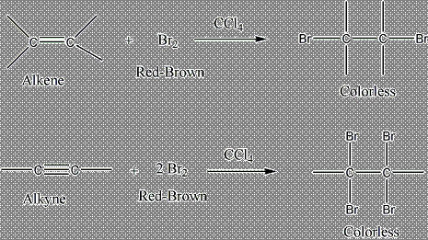

This is done as a demo in pre-lab
B. Potassium Permanganate (the Baeyer Test) A second qualitative test for unsaturation, the Baeyer test, depends on the ability of potassium permanganate to oxidize the carbon-carbon double bond to give alkanediols or the carbon-carbon triple bond to give carboxylic acids

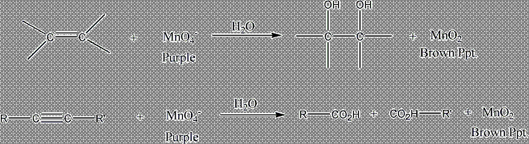

The permanganate is destroyed in the reaction, and a brown precipitate of MnO₂ is produced. The disappearance of the characteristic color of the permanganate ion is a positive test for unsaturation. However, care must be taken, since compounds containing certain other types of functional groups (for example, aldehydes, containing the --CH=O group) also decolorize permanganate ion.

EXPERIMENTAL:

a) Place one drop of cyclohexane in a depression of a white spot plate and add 1 drop of KMnO_{4.} A purple color should be observed, indicating no reaction. Stir the solution with a glass stirring rod and spot the solution onto a piece of filter paper. A purple spot should be visible on the filter paper.

b) Place one drop of cyclohexene in a depression of a white spot plate and add 1 drop of KMnO_{4.} A red-brown color should form indicating a positive reaction. Stir the solution with a glass stirring rod and spot the solution onto a piece of filter paper. A brown spot should be visible on the filter paper.

c) Place one drop of your product in another depression of a white spot plate, and add 1 drop KMnO_{4.} A red-brown color should form indicating a positive reaction. Stir the solution with a stirring rod and spot the solution onto a piece of filter paper. A brown spot should be visible on the filter paper.

